**ITW miniproject report**

**Names: Srujan Kale & Aditya Patil**

**Div/Batch: A/A2**

**Roll nos: 231028 & 231046**

**PRN : 22011200 & 22010162**

**Introduction:**

A Music Player is a simple audio player used to play audio/sound files and is heavily used to play music on computers. Purely audio files require a certain software, that is where audio players come in.

In this Music player we can select the audio file we want to play and change the track at our will. The music player is also able to Pause and Unpause the audio at our will.

**Implementation:**

import pygame  
import tkinter as tkr  
from tkinter.filedialog import askdirectory  
import os  
  
# part1  
  
music_player = tkr.Tk()  
music_player.title("My Music Player")  
music_player.geometry("450x350")  
directory = askdirectory()  
os.chdir(directory)  
song_list = os.listdir()  
# part 2   
play_list = tkr.Listbox(music_player, font="Helvetica 12 bold", bg='yellow', selectmode=tkr.SINGLE)  
for item in song_list:  
 pos = 0  
 play_list.insert(pos, item)  
 pos += 1  
pygame.init()  
pygame.mixer.init()  
  
def play():  
 pygame.mixer.music.load(play_list.get(tkr.ACTIVE))  
 var.set(play_list.get(tkr.ACTIVE))  
 pygame.mixer.music.play()  
def stop():  
 pygame.mixer.music.stop()  
def pause():  
 pygame.mixer.music.pause()  
def unpause():  
 pygame.mixer.music.unpause()  
Button1 = tkr.Button(music_player, width=5, height=3, font="Helvetica 12 bold", text="PLAY", command=play, bg="silver", fg="white")  
Button2 = tkr.Button(music_player, width=5, height=3, font="Helvetica 12 bold", text="STOP", command=stop, bg="red", fg="white")  
Button3 = tkr.Button(music_player, width=5, height=3, font="Helvetica 12 bold", text="PAUSE", command=pause, bg="purple", fg="white")  
Button4 = tkr.Button(music_player, width=5, height=3, font="Helvetica 12 bold", text="UNPAUSE", command=unpause, bg="orange", fg="white")  
  
var = tkr.StringVar()   
song_title = tkr.Label(music_player, font="Helvetica 12 bold", textvariable=var)  
  
song_title.pack()  
Button1.pack(fill="x") # only fills the section horizontally  
Button2.pack(fill="x")  
Button3.pack(fill="x")  
Button4.pack(fill="x")  
play_list.pack(fill="both", expand="yes")# both hori and vertically  
music_player.mainloop()

**Output:**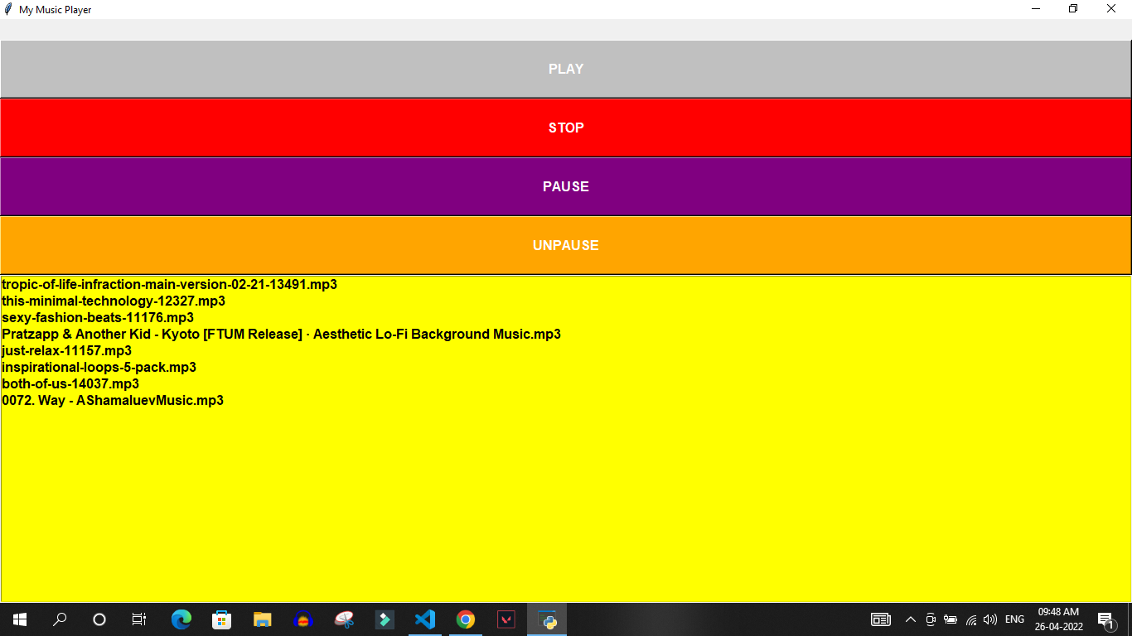

**Conclusion and Future Scope:**

In conclusion we learned how to use Pygame and Tkinter in Python and learned to make an entirely functional Music/Audio player.

The Music player seems to have almost nothing more to add in it’s future. It has served its purpose to the max. However there are still some occasional options or actions we can still have in an Audio player. These includes, cutting, mixing, playing in reverse, changing the pitch, frequency and tone of certain sounds and lots more.